Aim: Perform Gray level operations images.
Program:
import cv2
import numpy as np
import matplotlib.pyplot as plt

image_path = r'C:\Users\USER\Pictures\Camera Roll\exp-7.jpg'

src_image = cv2.imread(image_path, cv2.IMREAD_GRAYSCALE)

if src_image is None:
print("Image not found!")
exit()

# 1. Negative Transformation
negative_image = 255 - src_image

# 2. Thresholding (Pass the image array, unpack both tuple return values)
_, thresholded_image = cv2.threshold(src_image, 128, 255, cv2.THRESH_BINARY)

# 3. Gamma Correction
gamma = 2.0
normalized_image = src_image / 255.0
gamma_corrected_image = np.power(normalized_image, 1/gamma)
gamma_corrected_image = np.uint8(gamma_corrected_image * 255)

# Visualization
plt.figure(figsize=(15, 5))

plt.subplot(1, 4, 1)
plt.imshow(src_image, cmap='gray')
plt.title("Original")
plt.axis('off')

plt.subplot(1, 4, 2)
plt.imshow(negative_image, cmap='gray')
plt.title("Negative")
plt.axis('off')

plt.subplot(1, 4, 3)
plt.imshow(thresholded_image, cmap='gray')
plt.title("Threshold")
plt.axis('off')

plt.subplot(1, 4, 4)
plt.imshow(gamma_corrected_image, cmap='gray')
plt.title("Gamma")
plt.axis('off')

plt.show()

Output:
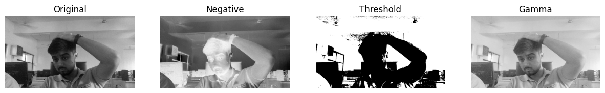
Conclusion: In this experiment, various spatial domain point-processing operations were successfully implemented on a grayscale image to analyze their pixel-level enhancements. The image negative transformation effectively inverted the intensity values, mapping light regions to dark and vice versa to emphasize detail in darker backgrounds. Binary thresholding at intensity cutoff 128 successfully segmented the primary foreground subject from the background into a stark, two-tone binary output. Finally, applying gamma correction (gamma = 2.0) adjusted the non-linear dynamic luminance, effectively brightening the mid-tone regions and enhancing overall contrast in underexposed areas of the image.

